|  |  |  |
| --- | --- | --- |
| Program | B.Tech Computer Engineering | |
| Semester | IV | |
| Name of the Project: | ResQFood | |
|  | | |
| Details of Project Members |  |  |
| Batch: 1 | Roll No.: A082 | Name: Mahek Mushrif |
| Date of Submission: 2nd April 2023 | | |

**Contribution of each project Members:**

|  |  |  |
| --- | --- | --- |
| Roll No. | Name: | Contribution |
|  |  |  |
|  |  |  |

**Github link of your project:**

**Project Report**



**by**

**Mahek Mushrif, Roll number: A082**

**Course: DBMS**

**AY: 2023-24**

**Table of Contents**

|  |  |  |
| --- | --- | --- |
| **Sr no.** | **Topic** | **Page no.** |
| **1** | Storyline | 4 |
| **2** | Components of Database Design | 5 |
| **3** | Entity Relationship Diagram | 8 |
| **4** | Relational Model | 9 |
| **5** | Normalization | 9 |
| **6** | Code | 10 |
| **7** | SQL Queries | 14 |
| **8** | Project Demonstration | 22 |
| **9** | Self-learning beyond classroom | 24 |
| **10** | Learning from the project | 25 |
| **8** | Challenges faced | 25 |
| **9** | Conclusion | 26 |

**Storyline**

**Introduction:**

In a world where food wastage is rampant and hunger persists, ResQFood emerges as a beacon of hope. As a second-year computer engineering student, I am excited to present the concept of ResQFood, a potential game-changer in the fight against food wastage and hunger.

**Statistics:**

Consider the staggering statistics: Globally, about one-third of all food produced for human consumption is wasted annually, while millions still suffer from malnutrition and hunger.

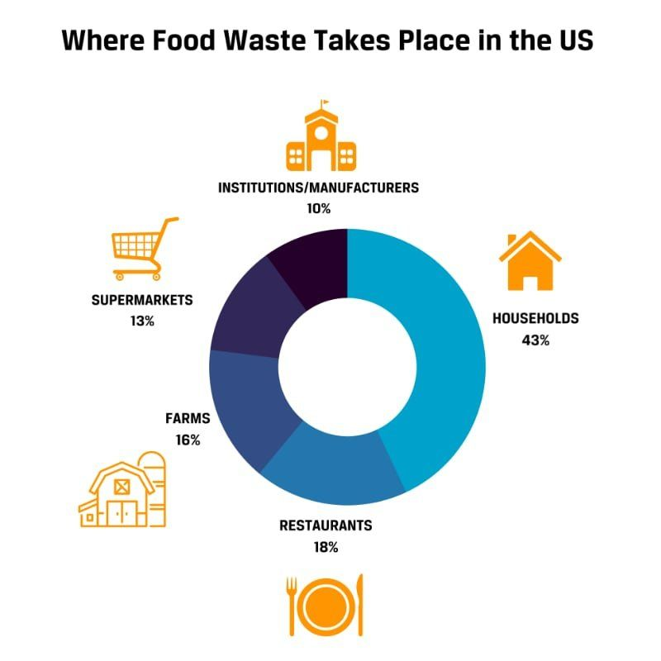 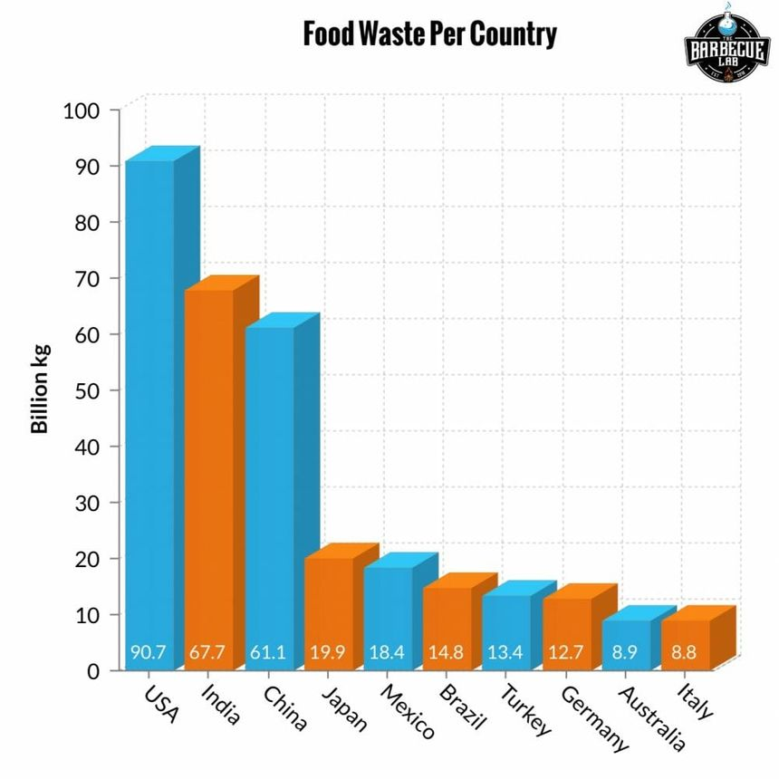

**Purpose:**

ResQFood is poised to bridge this gap between surplus food and those in need. Our platform will serve as a digital intermediary, connecting food donors with recipients in a seamless and efficient manner. Through a robust DBMS, ResQFood aims to achieve the following:

1. **Donor Integration:** Empower restaurants, event caterers, supermarkets, and other potential donors to upload surplus food information effortlessly onto the platform.

2. **Recipient Matching**: Utilize advanced algorithms to match food donations with nearby recipient organizations such as homeless shelters and community kitchens, ensuring optimal distribution.

3. **Logistics Optimization:** Streamline logistics to minimize food wastage during transportation and distribution, maximizing the impact of each donation.

4. **Data Analytics:** Leverage data analytics to identify trends in food wastage and hunger hotspots, enabling targeted interventions and resource allocation.

**What the Platform Does:**

ResQFood isn't just a website; it's a catalyst for change. By harnessing the power of technology, we aim to:

- Rescue millions of pounds of surplus food annually.

- Distribute food to thousands of individuals facing food insecurity.

- Reduce food wastage and promote sustainability within communities served by ResQFood.

In conclusion, ResQFood represents a vision for a more equitable and sustainable future. While still in the conceptual stage, the potential impact of ResQFood is undeniable. With your support, we can turn this idea into a reality and make a tangible difference in the lives of millions. Join us in our mission to rescue food and save lives with ResQFood.

**Components of Database Design**

**1. User:**

- Attributes:

- user_id (Primary Key): Unique identifier for each user.

- username: Name chosen by the user for identification.

- password: User's password for authentication.

- email: Email address of the user.

- role: Role of the user (e.g., donor, recipient, admin).

- Cardinality: Each user can have only one role.

- Participation: Every user must have a role assigned.

**2. Donor:**

- Attributes:

- donor_id (Primary Key): Unique identifier for each donor.

- user_id (Foreign Key): References the user_id of the corresponding User.

- donor_name: Name of the donor.

- contact_number: Contact number of the donor.

- address: Address of the donor.

- Relationships:

- Cardinality: (1,1) User -- (0,1) Donor

A donor can donate multiple food items.

- Participation: Mandatory on both sides

Every user can choose to be a donor or not.

**3. Recipient:**

- Attributes:

- recipient_id (Primary Key): Unique identifier for each recipient.

- user_id (Foreign Key): References the user_id of the corresponding User.

- recipient_name: Name of the recipient.

- contact_number: Contact number of the recipient.

- address: Address of the recipient.

- Relationships:

- Cardinality: (1,1) User -- (0,1) Recipient

A recipient can receive donations from multiple donors.

- Participation: Mandatory on both sides

Every user can choose to be a recipient or not.

**4. FoodItem:**

- Attributes:

- food_id (Primary Key): Unique identifier for each food item.

- donor_id (Foreign Key): References the donor_id of the corresponding Donor.

- food_name: Name of the food item.

- food_description: Description of the food item.

- quantity: Quantity of the food item available.

- expiry_date: Date when the food item expires.

- Relationships:

- Cardinality: (1,*) Donor -- (0,*) FoodItem

Each food item belongs to only one donor.

- Participation: Optional on FoodItem side

A donor may or may not donate food items.

**5. Donation:**

- Attributes:

- donation_id (Primary Key): Unique identifier for each donation.

- donor_id (Foreign Key): References the donor_id of the corresponding Donor.

- recipient_id (Foreign Key): References the recipient_id of the corresponding Recipient.

- donation_date: Date when the donation was made.

- status: Status of the donation (e.g., pending, delivered).

- Relationships:

- Cardinality: (1,*) Donor -- (1,*) Donation

A donor can make multiple donations, and each donation can have only one recipient.

- Participation: Mandatory on both sides

Every donation must have a donor and a recipient.

**6. Delivery:**

- Attributes:

- delivery_id (Primary Key): Unique identifier for each delivery.

- donation_id (Foreign Key): References the donation_id of the corresponding Donation.

- delivery_date: Date when the delivery was made.

- delivery_status: Status of the delivery (e.g., delivered, pending).

- Relationships:

- Cardinality: (1,1) Donation -- (0,1) Delivery

Each donation can have one delivery.

- Participation: Optional on Delivery side

A delivery may or may not be associated with a donation.

**7. Feedback:**

- Attributes:

- feedback_id (Primary Key): Unique identifier for each feedback.

- user_id (Foreign Key): References the user_id of the corresponding User.

- feedback_message: Message containing feedback.

- feedback_date: Date when the feedback was given.

- Relationships:

- Cardinality: (1,*) User -- (0,*) Feedback

Each user can give feedback multiple times.

- Participation: Mandatory on Feedback side

Feedback is optional for users.

**8. Admin:**

- Attributes:

- admin_id (Primary Key): Unique identifier for each admin.

- user_id (Foreign Key): References the user_id of the corresponding User.

- Relationships:

- Cardinality: (1,1) Admin -- (1,1) User.

Each admin is associated with only one user.

- Participation: Mandatory on both sides

Every user must have an admin role assigned or not.

**9. Category:**

- Attributes:

- category_id (Primary Key): Unique identifier for each category.

- category_name: Name of the category.

- Cardinality: Each category can have multiple food items associated with it.

- Participation: Categories are mandatory for food items.

**10. FoodCategory:**

- Attributes:

- food_category_id (Primary Key): Unique identifier for each food category.

- food_id (Foreign Key): References the food_id of the corresponding FoodItem.

- category_id (Foreign Key): References the category_id of the corresponding Category.

- Relationships:

- Cardinality: (1,*) FoodItem -- (0,*) FoodCategory

- Cardinality: (1,*) Category -- (0,*) FoodCategory

Each food item can belong to multiple categories, and each category can have multiple food items.

- Participation: Mandatory on both sides for both relationships

Food items and categories are optional for each other.

**Entity Relationship Diagram**

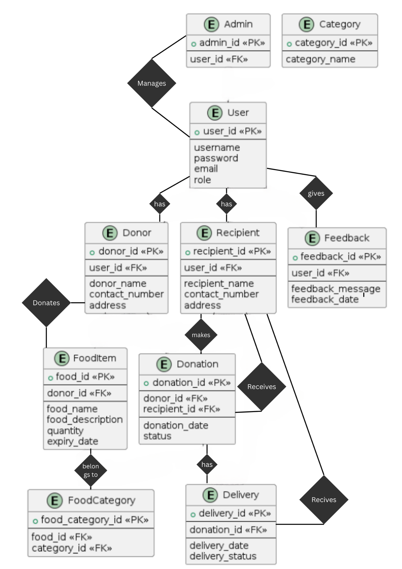

**Relational Model**

1. user(user_id, username, password, email, role)
2. donor(donor_id, user_id, donor_name, contact_number, address)

Foreign Key: user_id references User(user_id)

1. recipient(recipient_id, user_id, recipient_name, contact_number, address)

Foreign Key: user_id references User(user_id)

1. food_item(food_id, donor_id, food_name, food_description, quantity, expiry_date) Foreign Key: donor_id references Donor(donor_id)
2. donation(donation_id, donor_id, recipient_id, donation_date, status)

Foreign Keys:

- donor_id references Donor(donor_id)- recipient_id references Recipient(recipient_id)

6. delivery(delivery_id, donation_id, delivery_date, delivery_status)

- Foreign Key: donation_id references Donation(donation_id)

7. feedback(feedback_id, user_id, feedback_message, feedback_date)

- Foreign Key: user_id references User(user_id)

8. admin(admin_id, user_id)

- Foreign Key: user_id references User(user_id)

9. category(category_id, category_name)

10. food_category(food_category_id, food_id, category_id)

- Foreign Keys:

- food_id references FoodItem(food_id)

- category_id references Category(category_id)

**Normalization**

1NF (First Normal Form):

- All tables already comply with 1NF as they contain only atomic values without repeating groups.

2NF (Second Normal Form):

- All non-prime attributes are fully functionally dependent on the primary key.

- Move `food_description` from the FoodItem table to a new table (food_description) with `food_name` and `expiry_date` as its primary key.

3NF (Third Normal Form):

- No transitive dependencies exist.

- All non-prime attributes depend only on the primary key.

- The Donation table already satisfies 3NF.

BCNF (Boyce-Codd Normal Form):

- Every determinant is a candidate key.

- All tables are in BCNF.

The database is now normalized to 1NF, 2NF, 3NF, and BCNF as applicable.

**CODE:**

create database db;

use db;

CREATE TABLE User (

user_id INT PRIMARY KEY,

username VARCHAR(50),

password VARCHAR(50),

email VARCHAR(100),

role VARCHAR(20)

);

CREATE TABLE Donor (

donor_id INT PRIMARY KEY,

user_id INT,

donor_name VARCHAR(100),

contact_number VARCHAR(20),

address VARCHAR(255),

FOREIGN KEY (user_id) REFERENCES User(user_id)

);

CREATE TABLE Recipient (

recipient_id INT PRIMARY KEY,

user_id INT,

recipient_name VARCHAR(100),

contact_number VARCHAR(20),

address VARCHAR(255),

FOREIGN KEY (user_id) REFERENCES User(user_id)

);

CREATE TABLE FoodItem (

food_id INT PRIMARY KEY,

donor_id INT,

food_name VARCHAR(100),

food_description VARCHAR(255),

quantity INT,

expiry_date DATE,

FOREIGN KEY (donor_id) REFERENCES Donor(donor_id)

);

CREATE TABLE Donation (

donation_id INT PRIMARY KEY,

donor_id INT,

recipient_id INT,

donation_date DATE,

status VARCHAR(50),

FOREIGN KEY (donor_id) REFERENCES Donor(donor_id),

FOREIGN KEY (recipient_id) REFERENCES Recipient(recipient_id)

);

CREATE TABLE Delivery (

delivery_id INT PRIMARY KEY,

donation_id INT,

delivery_date DATE,

delivery_status VARCHAR(50),

FOREIGN KEY (donation_id) REFERENCES Donation(donation_id)

);

CREATE TABLE Feedback (

feedback_id INT PRIMARY KEY,

user_id INT,

feedback_message TEXT,

feedback_date DATE,

FOREIGN KEY (user_id) REFERENCES User(user_id)

);

CREATE TABLE Admin (

admin_id INT PRIMARY KEY,

user_id INT,

FOREIGN KEY (user_id) REFERENCES User(user_id)

);

CREATE TABLE Category (

category_id INT PRIMARY KEY,

category_name VARCHAR(100)

);

CREATE TABLE FoodCategory (

food_category_id INT PRIMARY KEY,

food_id INT,

category_id INT,

FOREIGN KEY (food_id) REFERENCES FoodItem(food_id),

FOREIGN KEY (category_id) REFERENCES Category(category_id)

);

INSERT INTO User (user_id, username, password, email, role) VALUES

(1, 'JohnDoe', 'password123', 'john.doe@example.com', 'donor'),

(2, 'JaneSmith', 'qwerty456', 'jane.smith@example.com', 'recipient'),

(3, 'AliceJohnson', 'abcdef789', 'alice.johnson@example.com', 'donor'),

(4, 'DavidBrown', '123456xyz', 'david.brown@example.com', 'recipient'),

(5, 'EmilyWilson', 'password321', 'emily.wilson@example.com', 'donor'),

(6, 'MichaelDavis', 'pass123word', 'michael.davis@example.com', 'recipient'),

(7, 'SamanthaTaylor', 'abcxyz789', 'samantha.taylor@example.com', 'donor'),

(8, 'DanielClark', 'daniel123', 'daniel.clark@example.com', 'recipient'),

(9, 'JenniferMartinez', 'qwerty789', 'jennifer.martinez@example.com', 'donor'),

(10, 'ChristopherLee', 'password789', 'christopher.lee@example.com', 'recipient'),

(11, 'AmandaWhite', 'abcdef123', 'amanda.white@example.com', 'donor'),

(12, 'MatthewHall', 'pass789word', 'matthew.hall@example.com', 'recipient'),

(13, 'JessicaLopez', '123456abc', 'jessica.lopez@example.com', 'donor'),

(14, 'AndrewKing', 'andrew123', 'andrew.king@example.com', 'recipient'),

(15, 'SarahGarcia', 'pass456word', 'sarah.garcia@example.com', 'donor'),

(16, 'JamesAnderson', 'passwordabc', 'james.anderson@example.com', 'recipient'),

(17, 'ElizabethMartinez', 'elizabeth123', 'elizabeth.martinez@example.com', 'donor'),

(18, 'RyanTaylor', 'passxyzword', 'ryan.taylor@example.com', 'recipient'),

(19, 'LaurenHernandez', 'lauren123', 'lauren.hernandez@example.com', 'donor'),

(20, 'BrandonYoung', 'pass123xyz', 'brandon.young@example.com', 'recipient');

INSERT INTO Donor (donor_id, user_id, donor_name, contact_number, address) VALUES

(1, 1, 'John Doe Foundation', '+1234567890', '123 Main Street, Cityville, USA'),

(2, 3, 'Alices Restaurant', '+1987654321', '456 Elm Street, Townsville, USA'),

(3, 5, 'Emilys Catering', '+1122334455', '789 Oak Avenue, Villagetown, USA'),

(4, 7, 'Samanthas Bakery', '+1567890123', '234 Maple Drive, Hamletville, USA'),

(5, 9, 'Jennifers Food Bank', '+1324354657', '567 Pine Lane, Boroughburg, USA'),

(6, 11, 'Amandas Café', '+1789456123', '890 Cedar Road, Villageville, USA'),

(7, 13, 'Jessicas Diner', '+1246384756', '345 Cherry Street, Townburg, USA'),

(8, 15, 'Sarahs Soup Kitchen', '+1987654321', '678 Walnut Avenue, Citytown, USA'),

(9, 17, 'Elizabeths Eatery', '+1122334455', '901 Pine Street, Countyville, USA'),

(10, 19, 'Laurens Deli', '+1876543210', '234 Oak Lane, Villagetown, USA');

INSERT INTO Recipient (recipient_id, user_id, recipient_name, contact_number, address) VALUES

(1, 2, 'Janes Shelter', '+1234567890', '123 Shelter Street, Cityville, USA'),

(2, 4, 'Davids Homeless Center', '+1987654321', '456 Hope Avenue, Townsville, USA'),

(3, 6, 'Michaels Soup Kitchen', '+1122334455', '789 Nourish Lane, Villagetown, USA'),

(4, 8, 'Daniels Food Pantry', '+1567890123', '234 Care Drive, Hamletville, USA'),

(5, 10, 'Chriss Community Kitchen', '+1324354657', '567 Nourishment Boulevard, Boroughburg, USA'),

(6, 12, 'Matthews Outreach Center', '+1789456123', '890 Serve Road, Villageville, USA'),

(7, 14, 'Andrews Hunger Relief', '+1246384756', '345 Caregiver Street, Townburg, USA'),

(8, 16, 'Jamess Assistance Program', '+1987654321', '678 Aid Avenue, Citytown, USA'),

(9, 18, 'Ryans Food Bank', '+1122334455', '901 Give Street, Countyville, USA'),

(10, 20, 'Brandons Nourish Fund', '+1876543210', '234 Serve Lane, Villagetown, USA');

INSERT INTO FoodItem (food_id, donor_id, food_name, food_description, quantity, expiry_date) VALUES

(1, 1, 'Canned Soup', 'Various flavors of canned soup', 100, '2024-04-30'),

(2, 2, 'Fresh Bread', 'Assorted loaves of freshly baked bread', 50, '2024-05-02'),

(3, 3, 'Frozen Vegetables', 'Mixed vegetables frozen for preservation', 75, '2024-04-28'),

(4, 4, 'Dessert Bars', 'Chocolate and vanilla dessert bars', 80, '2024-05-01'),

(5, 5, 'Canned Tuna', 'Canned tuna packed in water', 120, '2024-04-29'),

(6, 6, 'Fresh Fruits', 'Assorted fresh fruits including apples, oranges, and bananas', 60, '2024-05-03'),

(7, 7, 'Bakery Pastries', 'Freshly baked pastries including croissants and muffins', 90, '2024-04-30'),

(8, 8, 'Frozen Pizza', 'Assorted flavors of frozen pizzas', 70, '2024-04-27'),

(9, 9, 'Canned Vegetables', 'Various types of canned vegetables', 110, '2024-05-01'),

(10, 10, 'Deli Sandwiches', 'Assorted deli sandwiches with different fillings', 65, '2024-04-28');

INSERT INTO Donation (donation_id, donor_id, recipient_id, donation_date, status) VALUES

(1, 1, 1, '2024-04-15', 'Delivered'),

(2, 2, 2, '2024-04-16', 'In Transit'),

(3, 3, 3, '2024-04-17', 'Pending'),

(4, 4, 4, '2024-04-18', 'Delivered'),

(5, 5, 5, '2024-04-19', 'In Transit'),

(6, 6, 6, '2024-04-20', 'Pending'),

(7, 7, 7, '2024-04-21', 'Delivered'),

(8, 8, 8, '2024-04-22', 'In Transit'),

(9, 9, 9, '2024-04-23', 'Pending'),

(10, 10, 10, '2024-04-24', 'Delivered');

INSERT INTO Delivery (delivery_id, donation_id, delivery_date, delivery_status) VALUES

(1, 1, '2024-04-16', 'Delivered'),

(2, 3, '2024-04-18', 'In Transit'),

(3, 5, '2024-04-20', 'Pending'),

(4, 7, '2024-04-22', 'Delivered'),

(5, 9, '2024-04-24', 'In Transit'),

(6, 2, '2024-04-17', 'Pending'),

(7, 4, '2024-04-19', 'Delivered'),

(8, 6, '2024-04-21', 'In Transit'),

(9, 8, '2024-04-23', 'Pending'),

(10, 10, '2024-04-25', 'Delivered');

INSERT INTO Feedback (feedback_id, user_id, feedback_message, feedback_date) VALUES

(1, 1, 'Great experience with the donation process. Thank you!', '2024-04-20'),

(2, 3, 'The food received was fresh and delicious. Very grateful!', '2024-04-22'),

(3, 5, 'Appreciate the timely delivery of the food items. Excellent service!', '2024-04-24'),

(4, 7, 'The food quality could be improved. Some items were nearing expiry.', '2024-04-26'),

(5, 9, 'Received a variety of food items. Thank you for your generosity!', '2024-04-28');

INSERT INTO Admin (admin_id, user_id) VALUES

(1234, 2),

(5678, 6),

(9876, 10);

INSERT INTO Category (category_id, category_name) VALUES

(1, 'Canned Goods'),

(2, 'Bakery Items'),

(3, 'Fresh Produce'),

(4, 'Frozen Foods'),

(5, 'Desserts');

INSERT INTO FoodCategory (food_category_id, food_id, category_id) VALUES

(1, 1, 1),

(2, 2, 2),

(3, 3, 3),

(4, 4, 5),

(5, 5, 1),

(6, 6, 3),

(7, 7, 2),

(8, 8, 4),

(9, 9, 1),

(10, 10, 2);

select * from User;

select * from Donor;

select * from Recipient;

select * from FoodItem;

select * from Donation;

select * from Delivery;

select * from Feedback;

select * from Admin;

select * from Category;

select * from FoodCategory;

**SQL Queries**

1. Retrieve all users with their roles:

SELECT u.username, u.email, u.role

FROM User u;

OUTPUT

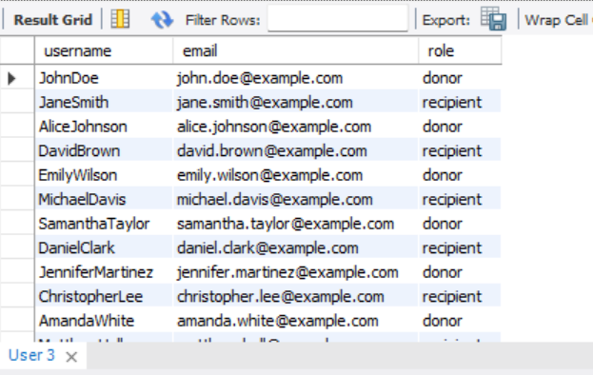 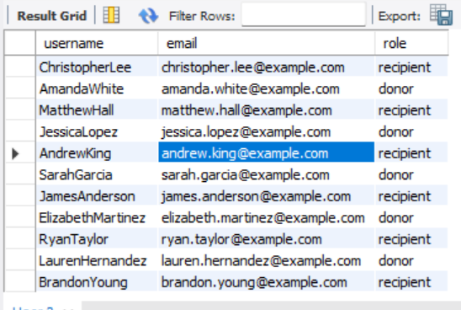

2. Retrieve donor details along with their donated food items:

SELECT d.donor_name, d.address, fi.food_name, fi.quantity, fi.expiry_date

FROM Donor d

JOIN FoodItem fi ON d.donor_id = fi.donor_id;

OUTPUT

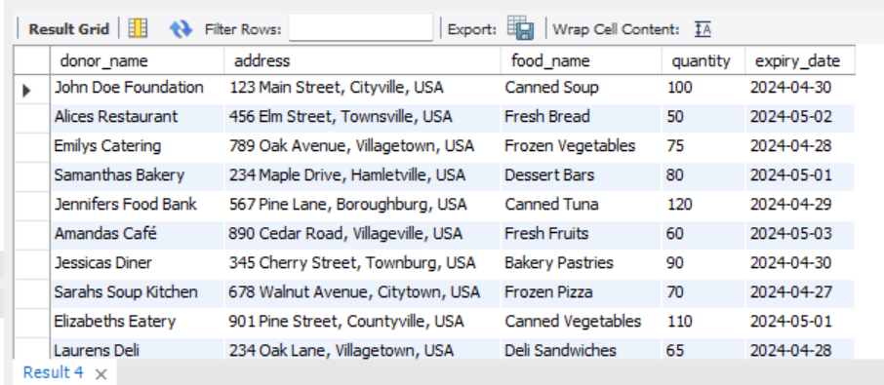

3. Retrieve recipient details along with the status of their donations:

SELECT r.recipient_name, r.address, d.status

FROM Recipient r

JOIN Donation d ON r.recipient_id = d.recipient_id;

OUTPUT

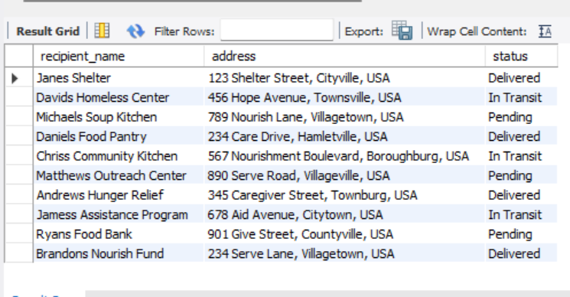

4. Retrieve all feedback messages given by users:

SELECT u.username, f.feedback_message, f.feedback_date

FROM User u

JOIN Feedback f ON u.user_id = f.user_id;

OUTPUT

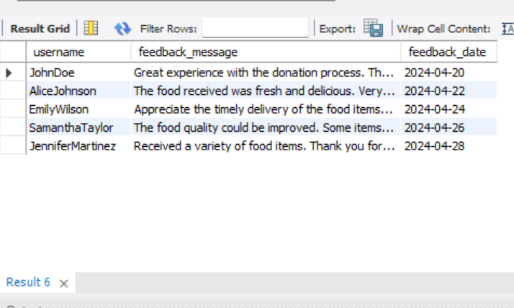

5. Retrieve all food items with their corresponding categories:

SELECT fi.food_name, c.category_name

FROM FoodItem fi

JOIN FoodCategory fc ON fi.food_id = fc.food_id

JOIN Category c ON fc.category_id = c.category_id;

OUTPUT

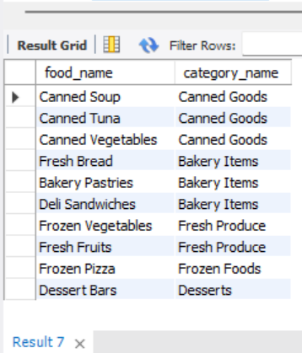

6. Retrieve all donations made by a specific donor:

SELECT d.donation_date, d.status

FROM Donation d

JOIN Donor dr ON d.donor_id = dr.donor_id

WHERE dr.donor_name = 'John Doe Foundation';

OUTPUT

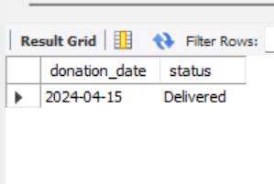

7. Retrieve all deliveries made on a specific date:

SELECT d.delivery_date, d.delivery_status

FROM Delivery d

WHERE d.delivery_date = '2024-04-22';

OUTPUT

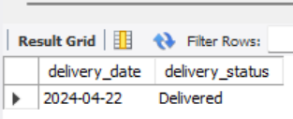

8. Retrieve the total quantity of each food item donated:

SELECT fi.food_name, SUM(fi.quantity) AS total_quantity

FROM FoodItem fi

GROUP BY fi.food_name;

OUTPUT

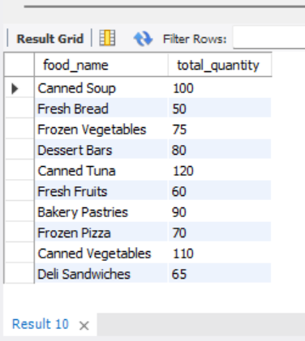

9. Retrieve the average quantity of food items donated by each donor:

SELECT d.donor_name, AVG(fi.quantity) AS average_quantity

FROM Donor d

JOIN FoodItem fi ON d.donor_id = fi.donor_id

GROUP BY d.donor_name;

OUTPUT

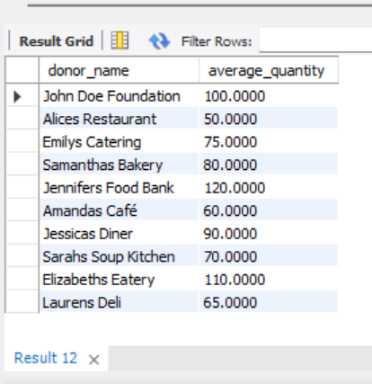

10. Retrieve the count of donations made by each donor:

SELECT d.donor_name, COUNT(*) AS donation_count

FROM Donor d

JOIN Donation dn ON d.donor_id = dn.donor_id

GROUP BY d.donor_name;

OUTPUT

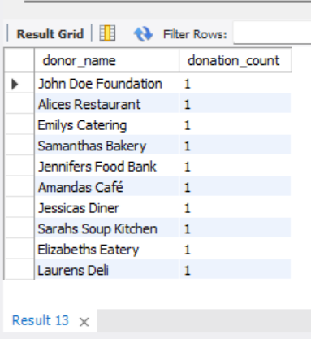

11. Retrieve the recipients who have pending donations:

SELECT r.recipient_name, d.donation_date

FROM Recipient r

JOIN Donation d ON r.recipient_id = d.recipient_id

WHERE d.status = 'Pending';

OUTPUT

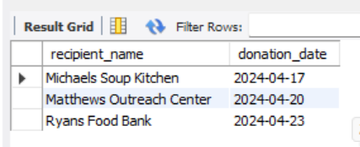

12. Retrieve all donors along with their contact numbers:

SELECT d.donor_name, d.contact_number

FROM Donor d;

OUTPUT

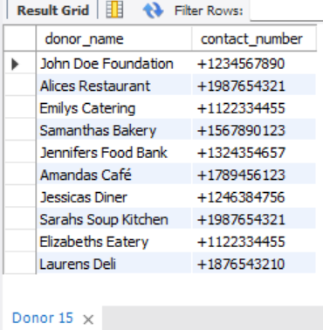

13. Retrieve all recipients along with their addresses:

SELECT r.recipient_name, r.address

FROM Recipient r;

OUTPUT

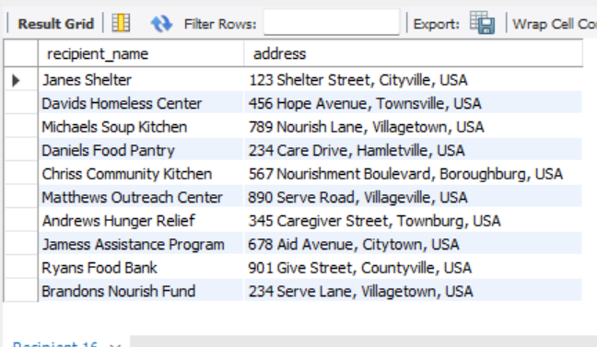

14. Retrieve the latest feedback given by each user:

SELECT u.username, f.feedback_message, f.feedback_date

FROM User u

JOIN Feedback f ON u.user_id = f.user_id

WHERE f.feedback_date = (

SELECT MAX(feedback_date)

FROM Feedback

WHERE user_id = u.user_id

);

OUTPUT

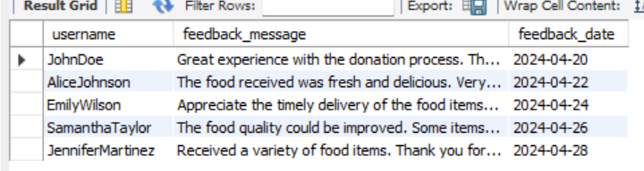

15. Retrieve the donors who have donated a specific food item:

SELECT d.donor_name, fi.food_name

FROM Donor d

JOIN FoodItem fi ON d.donor_id = fi.donor_id

WHERE fi.food_name = 'Canned Soup';

OUTPUT

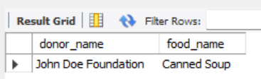

16. Retrieve the recipients who received donations on a specific date:

SELECT r.recipient_name, dn.donation_date

FROM Recipient r

JOIN Donation dn ON r.recipient_id = dn.recipient_id

WHERE dn.donation_date = '2024-04-20';

OUTPUT

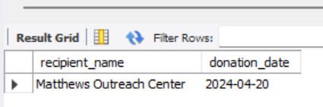

17. Retrieve the average quantity of each food category donated:

SELECT c.category_name, AVG(fi.quantity) AS average_quantity

FROM Category c

JOIN FoodCategory fc ON c.category_id = fc.category_id

JOIN FoodItem fi ON fc.food_id = fi.food_id

GROUP BY c.category_name;

OUTPUT

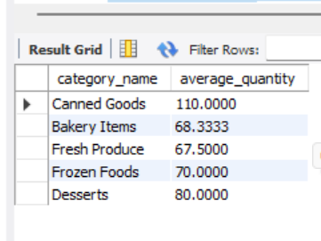

18. Retrieve the donors who have donated food items with a quantity greater than a specified value:

SELECT d.donor_name, fi.food_name, fi.quantity

FROM Donor d

JOIN FoodItem fi ON d.donor_id = fi.donor_id

WHERE fi.quantity > 50;

OUTPUT

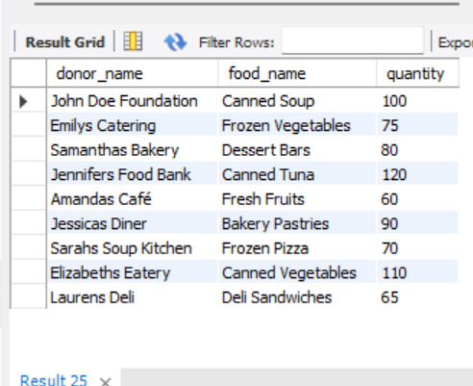

19. Retrieve the recipients who have pending deliveries:

SELECT r.recipient_name, d.delivery_date

FROM Recipient r

JOIN Donation dn ON r.recipient_id = dn.recipient_id

JOIN Delivery d ON dn.donation_id = d.donation_id

WHERE d.delivery_status = 'Pending';

OUTPUT

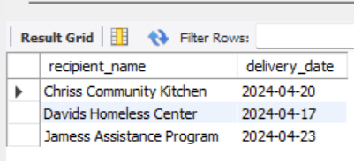

20. Retrieve the total count of donations made by each recipient:

SELECT r.recipient_name, COUNT(dn.donation_id) AS donation_count

FROM Recipient r

JOIN Donation dn ON r.recipient_id = dn.recipient_id

GROUP BY r.recipient_name;

OUTPUT

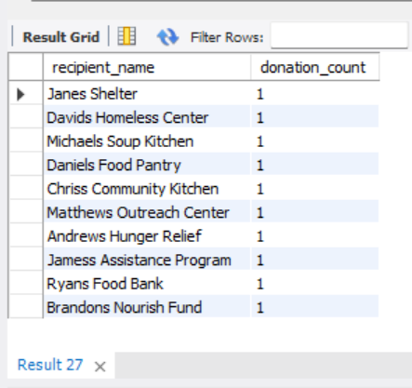

**Project demonstration**

For our Database Management System (DBMS) project, we utilized a range of tools, software, and libraries to design and implement a robust system. We employed MySQL as our primary relational database management system, allowing efficient data storage, retrieval, and management. To interface with the database, we utilized PHP for server-side scripting and handling dynamic content.

Additionally, we leveraged HTML, CSS, and JavaScript for creating an intuitive and interactive user interface. Our project also integrated libraries such as jQuery for client-side scripting, ensuring seamless interaction and responsiveness. Through this comprehensive approach, we developed a functional and user-friendly DBMS solution tailored to our project requirements.

**Proof Of Concept:**

**GitHub Repository Link: https://github.com/jxxt/ResQFood**

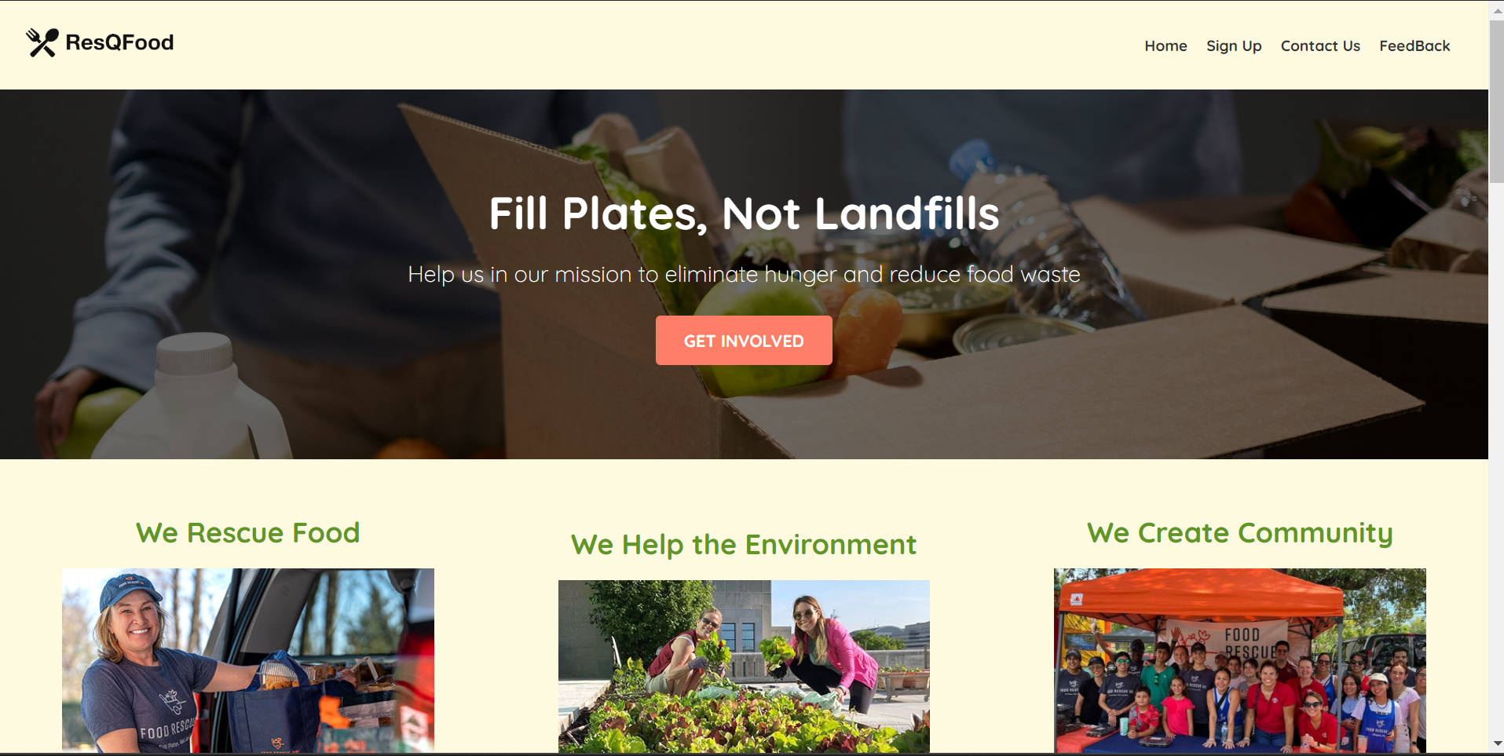

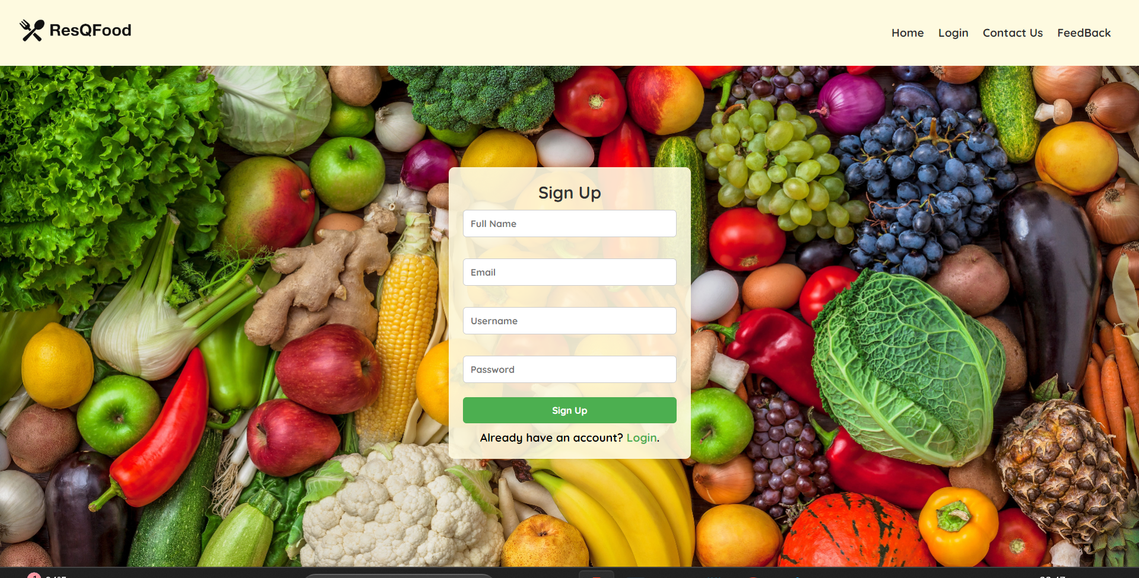

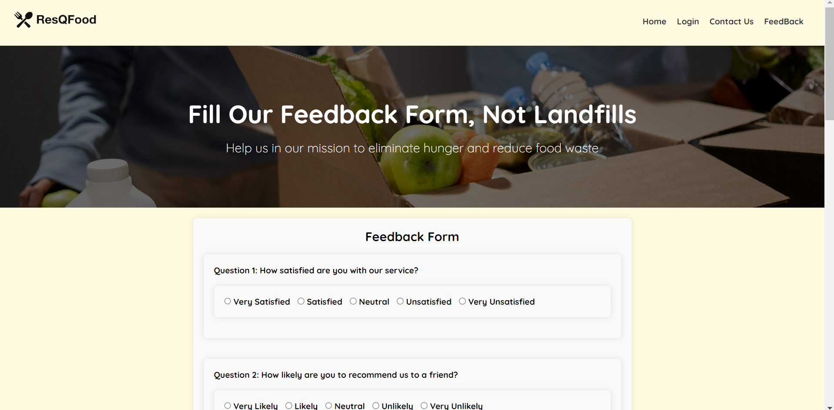

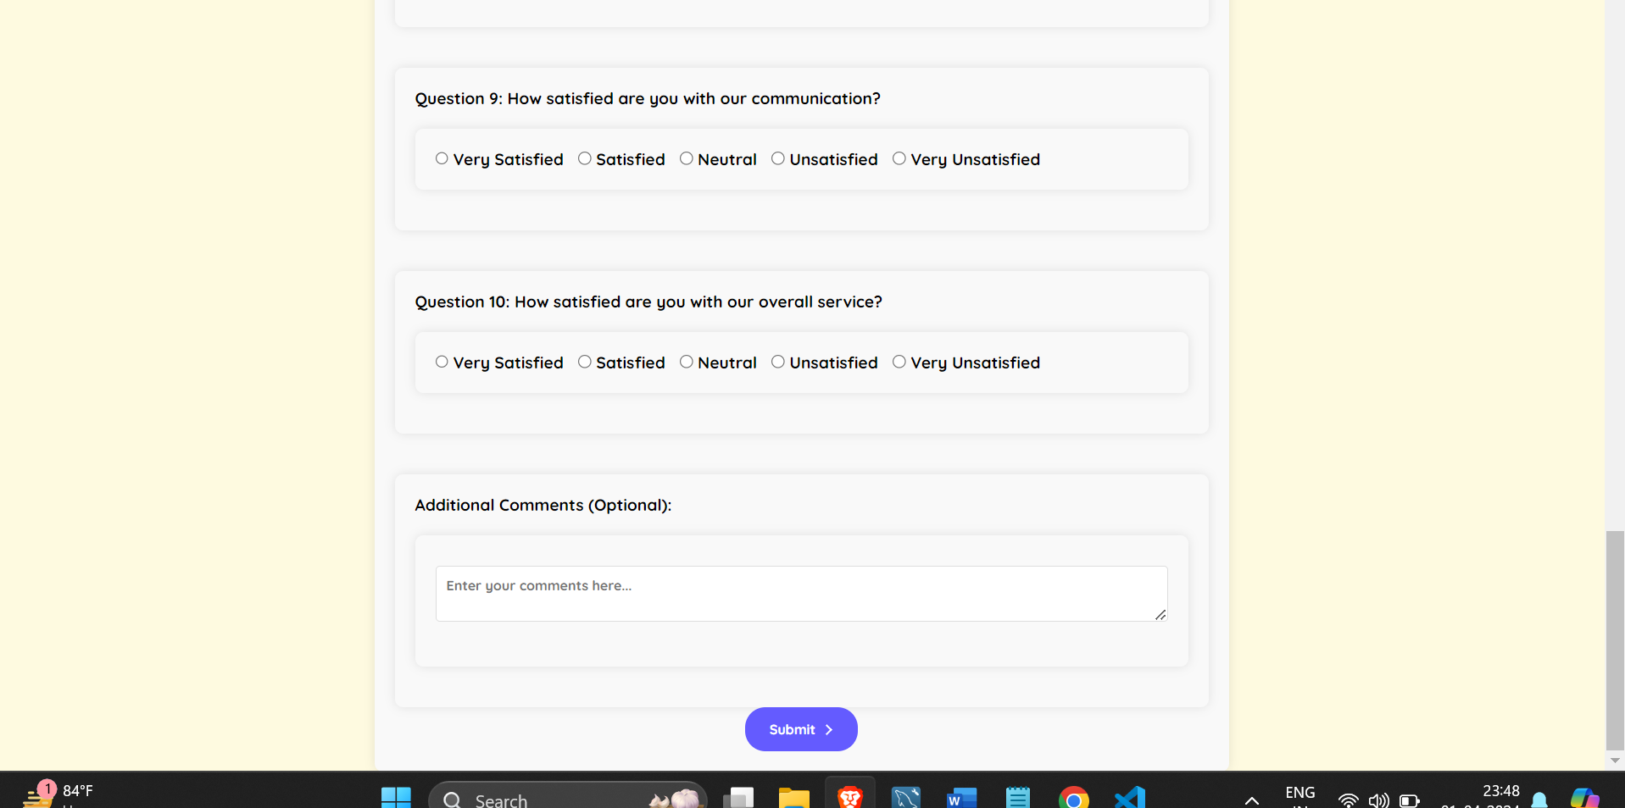

**Self -Learning beyond classroom**

During the project, I delved into various aspects beyond the classroom curriculum. This included:

1. **Advanced SQL techniques:** Explored complex SQL queries beyond basic CRUD operations to optimize database performance and enhance data retrieval.
2. **Web development:** Learned HTML, CSS, and JavaScript to develop a user-friendly interface, enabling seamless interaction with the database.
3. **PHP scripting:** Acquired proficiency in PHP for server-side scripting, facilitating dynamic content generation and database interaction.
4. **Database optimization:** Explored techniques to optimize database schema design and indexing for improved performance and scalability.
5. **Security practices:** Studied database security measures such as parameterized queries and input validation to mitigate SQL injection and other security threats.

**Learning from the Project:**

This project provided invaluable learning experiences, including:

1. **Application of theoretical concepts:** Applied classroom-learned database concepts such as normalization, relational modeling, and query optimization to a real-world scenario.
2. **Practical database management:** Gained hands-on experience in designing, implementing, and managing a relational database system using MySQL.
3. **Enhanced problem-solving skills:** Encountered various challenges during project development, fostering problem-solving skills and resourcefulness.
4. **Collaboration and teamwork:** Engaged in collaborative project development, improving communication, teamwork, and project management skills.
5. **Understanding user requirements:** Interacted with potential users to understand their needs and preferences, translating them into functional requirements for the project.

**Challenges Faced:**

During the project, I encountered several challenges, including:

* **Database schema design:** Designing an efficient and scalable database schema to accommodate diverse data requirements.
* **Query optimization:** Optimizing complex SQL queries to improve database performance and minimize response time.
* **User interface design:** Creating a visually appealing and intuitive user interface that meets user expectations and enhances usability.
* **Data validation:** Implementing robust data validation techniques to ensure data integrity and prevent security vulnerabilities.
* **Project timeline management:** Managing project timelines and milestones effectively to meet deadlines and deliver a high-quality product.

**Conclusion:**

From this project, I gained a deeper understanding of database management principles and practical implementation techniques. Key takeaways include:

* Proficiency in database design and management using MySQL.
* Improved problem-solving, teamwork, and communication skills through collaborative project development.
* Enhanced ability to translate user requirements into functional database solutions.
* Understanding of the importance of database optimization and security practices in real-world applications.
* Overall, the project provided a valuable opportunity to apply theoretical knowledge in a practical setting and develop essential skills for future endeavors in database management and software development.